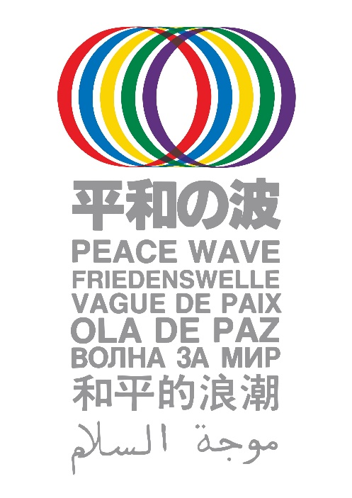*Please send the information of your Peace Wave*

*Action from August 6 to 9 to:*

*Peace Wave Action Committee:* ***intl@antiatom.org***

Name of the event/action: __________________________

Time/ Date: _____________________________________

Place: __________________________________________

City/Town: ________________ Country: _______________

Organizer: ________________________________________________________

Contact person: ___________________________________________________

Email address_____________________________________________________

URL: ___________________________________________________________

Other SNS: ______________________________________________________

Short description of planned action(s) for the Peace Wave:

*Peace Wave Action Committee:* [*intl@antiatom.org*](mailto:intl@antiatom.org)